 | 7.1.30 Editors - 3D Viewport - Header - Grease Pencil - Edit mode - Grease Pencil menu
Table of content
Detailed table of content 1
Edit Mode - Grease Pencil Menu 5
Transform 5
Bend 5
Shear 5
To Sphere 6
Shrink/Fatten 7
Mirror 8
Interactive Mirror 8
X Global, Y Global etc. 8
Snap 9
Last Operator Snap 9
Animation 9
Insert Blank Key frame ( Active Layer ) 9
Insert Blank Key frame ( All Layers ) 9
Last Operator Insert Blank Frame 9
Duplicate Active Key frame ( Active Layer ) 10
Duplicate Active Key frame ( All Layers ) 10
Last Operator Insert Blank Frame 10
Delete Active Key frame ( Active Layer ) 10
Delete Active Key frame ( All Layers ) 10
Single Operators 10
Interpolate Sequence 10
Duplicate 10
Duplicate Active Frame 11
Duplicate Active Frame All Layers 11
Split 12
Copy 12
Paste 12
Paste by Layer 12
Delete 12
Dissolve 13
Cleanup 13
Show / Hide 15
Separate 15

Detailed table of content
Detailed table of content
Detailed table of content 1
Edit Mode - Grease Pencil Menu 5
Transform 5
Bend 5
Shear 5
Last Operator Shear 5
Offset 5
Shear Axis 5
Axis 6
Axis Ortho 6
Orientation 6
Proportional editing 6
Proportional Falloff 6
Proportional Size 6
Connected 6
Projected(2D) 6
To Sphere 6
Usage 6
Last Operator To Sphere Panel 7
Factor 7
Proportional editing 7
Proportional Falloff 7
Proportional Size 7
Connected 7
Projected(2D) 7
Shrink/Fatten 7
Last Operator Shrink/Fatten 7
Offset 7
Offset Even 7
Proportional editing 7
Proportional Falloff 8
Proportional Size 8
Connected 8
Projected(2D) 8
Mirror 8
Interactive Mirror 8
X Global, Y Global etc. 8
Last Operator Mirror 8
Orientation 8
Constraint Axis 8
Proportional editing 8
Proportional Falloff 9
Proportional Size 9
Connected 9
Projected(2D) 9
Snap 9
Last Operator Snap 9
Offset 9
Animation 9
Insert Blank Key frame ( Active Layer ) 9
Insert Blank Key frame ( All Layers ) 9
Last Operator Insert Blank Frame 9
All Layers 9
Duplicate Active Key frame ( Active Layer ) 10
Duplicate Active Key frame ( All Layers ) 10
Last Operator Insert Blank Frame 10
Mode 10
Delete Active Key frame ( Active Layer ) 10
Delete Active Key frame ( All Layers ) 10
Single Operators 10
Interpolate Sequence 10
Duplicate 10
Last Operator Duplicate 11
Mode 11
Move X, Y, Z 11
Orientation 11
Constraint Axis 11
Proportional editing 11
Proportional Falloff 11
Proportional Size 11
Connected 11
Projected(2D) 11
Duplicate Active Frame 11
Duplicate Active Frame All Layers 11
Last Operator Duplicate Frame 12
Mode 12
Split 12
Copy 12
Paste 12
Paste by Layer 12
Last operator Paste Strokes 12
Type 12
Delete 12
Points 12
Strokes 12
Frame 12
Last Operator Delete 13
Type 13
Delete Active Key frame(Active Layer) 13
Delete Active Key frame(All Layers) 13
Dissolve 13
Dissolve 13
Dissolve Between 13
Dissolve Unselect 13
Last Operator Dissolve 13
Type 13
Cleanup 13
Boundary Strokes 13
Boundary Strokes all Frames 14
Last Operator Clean Fill Boundaries 14
Mode 14
Delete Loose Points 14
Last Operator Clean Loose Points 14
Limit 14
Merge by Distance 14
Last Operator Clean Loose Points 14
Threshold 14
Unselected 14
Delete Duplicated Frames 14
Last Operator Clean Duplicated Frames 14
Type 14
Recalculate Geometry 14
Re project Strokes 15
Re project Strokes menu 15
Last Operator Re project Strokes 15
Projection Type 15
Show / Hide 15
Show Hidden Layer 15
Hide Selected Layer 15
Last Operator Hide Layers 15
Unselected 15
Hide Unselected 15
Toggle Opacity 15
Separate 15
Selected Points 15
Selected Strokes 16
Active Layer 16
Last Operator Separate Strokes 16
Mode 16
Active Layer 16
Selected Strokes 16
Selected Points 16

Edit Mode - Grease Pencil Menu

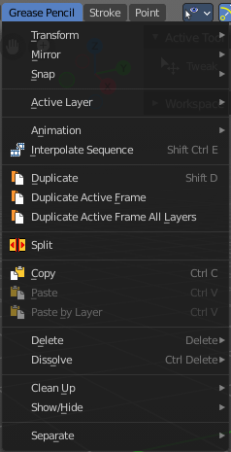

Transform

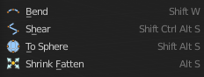

Bend
Bends the selection.

Shear
Shear shears the selection.


Last Operator Shear

Offset
Adjust an offset.

Shear Axis
The shear tool works along a imaginary 2d plane. The shear axis controls if the items are sheared along the x or the y axes of this plane. This is the plane along which the transformation happens. You can shear along the x or the y axis of this plane.
To make things even more complicated, the orientation of this imaginary plane is defined by the Axis and Axis Ortho items below.

Axis
Defines one axis of the imaginary shear axis plane.


Axis Ortho
Defines the other axis of the imaginary shear axis plane.

Orientation
Choose the orientation for the shear action.

Proportional editing

Enables proportional editing. Activating proportional editing reveals further settings.

Proportional Falloff
Adjust the falloff methods.

Proportional Size
See and adjust the falloff radius.

Connected
The proportional falloff gets calculated for connected parts only.

Projected(2D)
The proportional falloff gets calculated in the screen space. Depth doesn't play a role. When it's in the radius, then it gets calculated.

To Sphere
Shapes a selection of objects into the shape of a sphere. The calculation happens with the object origins.

Usage

Select the vertices, activate the tool, then drag the mouse in the 3D viewport. In the header you will read the current factor then. Which tells you how close you are towards the sphere shape.



Last Operator To Sphere Panel

Factor
The factor to transform the selection into a shape form.

Proportional editing
Enables proportional editing. Activating proportional editing reveals further settings.

Proportional Falloff
Adjust the falloff methods.

Proportional Size
See and adjust the falloff radius.

Connected
The proportional falloff gets calculated for connected parts only.

Projected(2D)
The proportional falloff gets calculated in the screen space. Depth doesn't play a role. When it's in the radius, then it gets calculated.

Shrink/Fatten
Shrink/Fatten scales the selected geometry along its normals. Transform orientation and Pivot point gets ignored.
A positive value pushes the vertices outwards. A negative value pushes the vertices inwards.


Last Operator Shrink/Fatten
The Last Operator Shrink/Fatten panel gives you tools to adjust the Shrink/Fatten operation. Here you have numeric input for the strength and a few more options.

Offset
Offset is the strength of the offset for Shrink/Fatten.

Offset Even
Offset Even scales the selection to give more thickness in even areas.

Proportional editing
Enables proportional editing. Activating proportional editing reveals further settings.

Proportional Falloff
Adjust the falloff methods.

Proportional Size
See and adjust the falloff radius.

Connected
The proportional falloff gets calculated for connected parts only.

Projected(2D)
The proportional falloff gets calculated in the screen space. Depth doesn't play a role. When it's in the radius, then it gets calculated.

Mirror

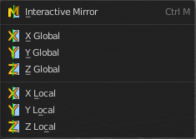
Mirror mirrors the selected geometry along the defined axis.

Interactive Mirror
Mirror by hotkeys. You activate the tool, type in x for x global for example, or x x for x local. And the selection gets mirrored.

X Global, Y Global etc.
Mirrors the selection around the chosen axis.

Last Operator Mirror

The Last Operator Mirror panel gives you tools to adjust the mirror action.

Orientation
Orientation is a drop-down box. Choose the type of orientation for the mirroring action.

Constraint Axis
Constraint Axis gives you again the possibility to define the mirror axis. You can choose more than one axis here.

Proportional editing
Enables proportional editing. Activating proportional editing reveals further settings.

Proportional Falloff
Adjust the falloff methods.

Proportional Size
See and adjust the falloff radius.

Connected
The proportional falloff gets calculated for connected parts only.

Projected(2D)
The proportional falloff gets calculated in the screen space. Depth doesn't play a role. When it's in the radius, then it gets calculated.

Snap
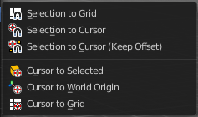
Choose several methods to snap one element to another. The menu items should be self explaining.

Last Operator Snap

Some snap operations shows a last operation panel, some not.

Offset
If the selection should snap as a whole, or if each individual element of the selection should snap.

Animation

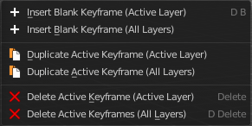
Insert Blank Key frame ( Active Layer )
Inserts a key frame into the active layer.

Insert Blank Key frame ( All Layers )
Inserts a key frame into all layers.

Last Operator Insert Blank Frame
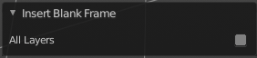
Some snap operations shows a last operation panel, some not.

All Layers
Insert into active layer or into all layers.

Duplicate Active Key frame ( Active Layer )
Duplicates the active key frame in the active layer.

Duplicate Active Key frame ( All Layers )
Duplicates the active key frame in all layers.

Last Operator Insert Blank Frame
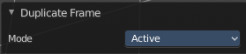
Some snap operations shows a last operation panel, some not.

Mode
Duplicate the active key frame in the active layer or in all layers.

Delete Active Key frame ( Active Layer )
Deletes the active key frame in the active layer.

Delete Active Key frame ( All Layers )
Deletes the active key frame in all layers

Single Operators

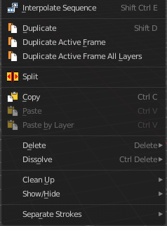
Interpolate Sequence
Interpolate strokes between the previous and next keyframe by adding multiple keyframes. When you are on a frame between two keyframes and click the sequence button, then a breakdown keyframe will be added on every frame between the previous and next keyframe.

Duplicate
Duplicates the current selection.
When you duplicate a selection, then it sticks to the mouse until you left click. And moves around. A right click repositions the duplicated geometry at its original location.

Last Operator Duplicate

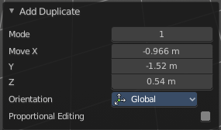
Mode
Not to find out. No tool tip, no entry in the Blender manual. Good Job Blender Developers.

Move X, Y, Z
Adjust the position.

Orientation
Orientation is a drop-down box. Choose the type of orientation for the mirroring action.

Constraint Axis
Constraint Axis gives you again the possibility to define the mirror axis. You can choose more than one axis here.

Proportional editing
Enables proportional editing. Activating proportional editing reveals further settings.

Proportional Falloff
Adjust the falloff methods.

Proportional Size
See and adjust the falloff radius.

Connected
The proportional falloff gets calculated for connected parts only.

Projected(2D)
The proportional falloff gets calculated in the screen space. Depth doesn't play a role. When it's in the radius, then it gets calculated.

Duplicate Active Frame
Duplicates the active frame in the active layer.

Duplicate Active Frame All Layers
Duplicates the active frame in all layers.

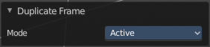
Last Operator Duplicate Frame

Mode
Choose between Duplicate Active Frame and Duplicate Active Frame All Layers.

Split
Splits the selection.

Copy
Copies the selection.

Paste
Pastes a copied selection to active layer. You can have more than one layer.

Paste by Layer
Pastes a copied selection to same, original layer. You can have more than one layer.

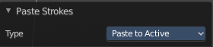
Last operator Paste Strokes

Type
Choose between the paste methods again.

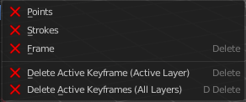
Delete

Points
Delete selected stroke points.

Strokes
Delete the stroke where the current selection belongs to.

Frame
Delete the grease pencil frame where the current selection belongs to.

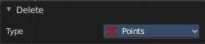
Last Operator Delete

Type
Choose what you want to delete.

Delete Active Key frame(Active Layer)
Deletes the active key frame in the current active layer.

Delete Active Key frame(All Layers)
Deletes the active key frame in all layers.

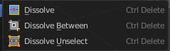
Dissolve
Dissolve is a union operation. Two edges becomes one edge by removing the vertice in between.

Dissolve
Dissolves the selection.

Dissolve Between
Dissolves the vertices between the selected vertices.

Dissolve Unselect
Dissolves the vertices that are not selected.

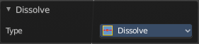
Last Operator Dissolve

Type
Choose how you want to dissolve.

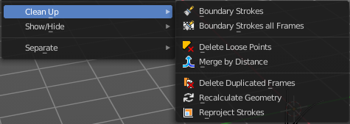
Cleanup

Boundary Strokes
Removes boundary "No Fill" strokes in the current active frame.

Boundary Strokes all Frames
Removes boundary "No Fill" strokes in the all frames.

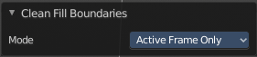
Last Operator Clean Fill Boundaries

Mode
Current active frame or all frames.

Delete Loose Points
Deletes not connected stroke geometry that is made of loose points.

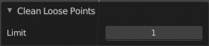
Last Operator Clean Loose Points

Limit
The number of vertices below which a stroke gets counted as a loose point.

Merge by Distance
Merges vertices that are close to each other.

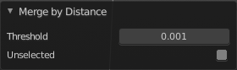
Last Operator Clean Loose Points

Threshold
The distance.

Unselected
Merge also unselected geometry.

Delete Duplicated Frames
Deletes all duplicated frames.

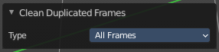
Last Operator Clean Duplicated Frames

Type
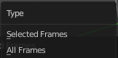
Delete just in the selected frames or in all frames.

Recalculate Geometry
Update all internal geometry data.

Re project Strokes
Re project the selected strokes onto a new plane from the current viewport. So that all strokes are on one plane.

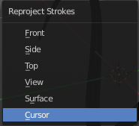
Re project Strokes menu
Using this tool opens a popup menu. Choose the projection type method.

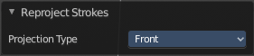
Last Operator Re project Strokes

Projection Type
A popup menu. Choose the projection type method.

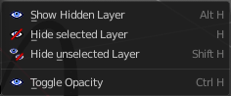
Show / Hide

Show Hidden Layer
Makes all layers in the scene visible again.

Hide Selected Layer
Hides the selected layer.

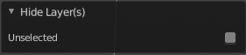
Last Operator Hide Layers

Unselected
Hides the not selected layers.

Hide Unselected
Hides the not selected layers. The selected layers stays visible.

Toggle Opacity
Toggles the opacity of the stroke. With opaque stroke the vertices are hidden behind the stroke, and can't be seen.

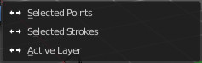
Separate
Separates the selection into a new grease pencil object.

Selected Points
Separate the selected points with its edges.

Selected Strokes
Separate the whole stroke of the current selection.

Active Layer
Separate all the strokes at the current active layer.

Last Operator Separate Strokes

Mode

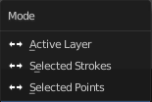
Active Layer
Separate all the strokes at the current active layer.

Selected Strokes
Separate the whole stroke of the current selection.

Selected Points
Separate the selected points with its edges.

